1.INTRODUCTION

1.1 Overview

This involves estimating all the expenses required to start and operate the business,such as equipment,rent,inventory,and marketing.By calculating these costs upfront ,business owners can better plan their budget and avoid unexpected expenses.

1.2 Purpose

Estimates are important because they allow business to set expectations for there customers.They also help busineses determine whether or not a project is feasible and how much profit they can expect to make. Estimating also allows businesses to plan for unforeseen expenses and keep track of spending.

2.1 EMPATHY MAP

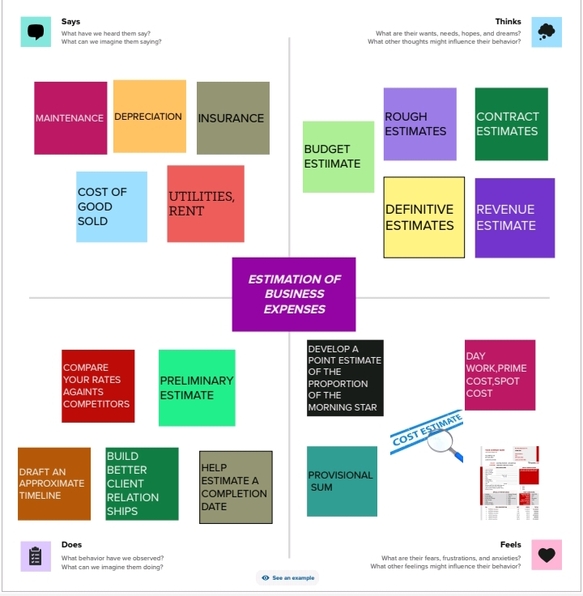

2.2 BRAIN STROMING MAP

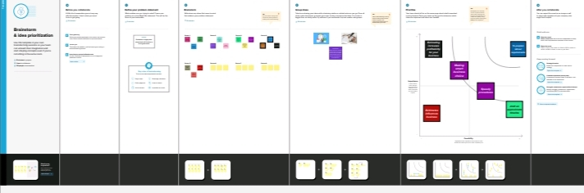

RESULT

Subtract your net income (or less) from the total revenue.If the result is negative,treat it as a net loss.

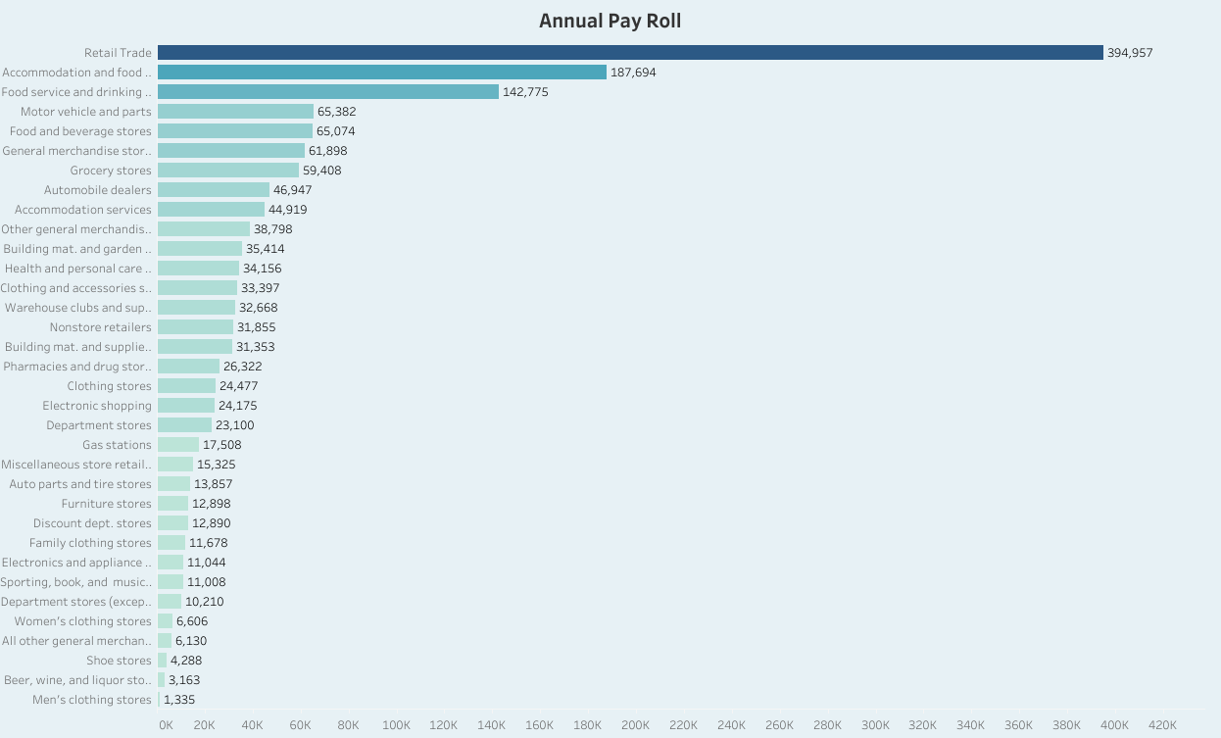

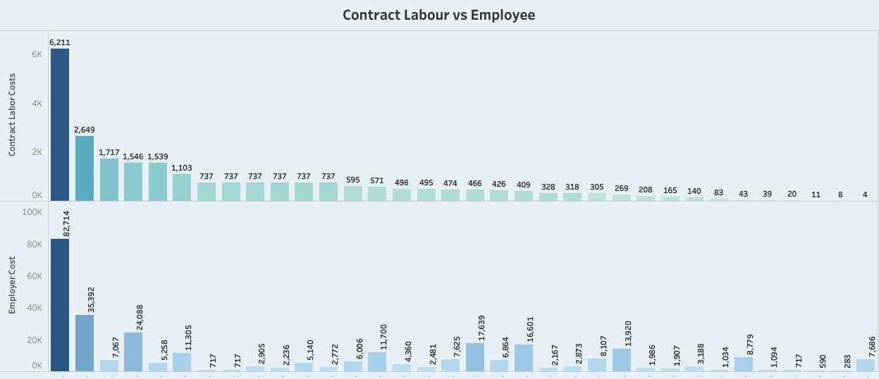

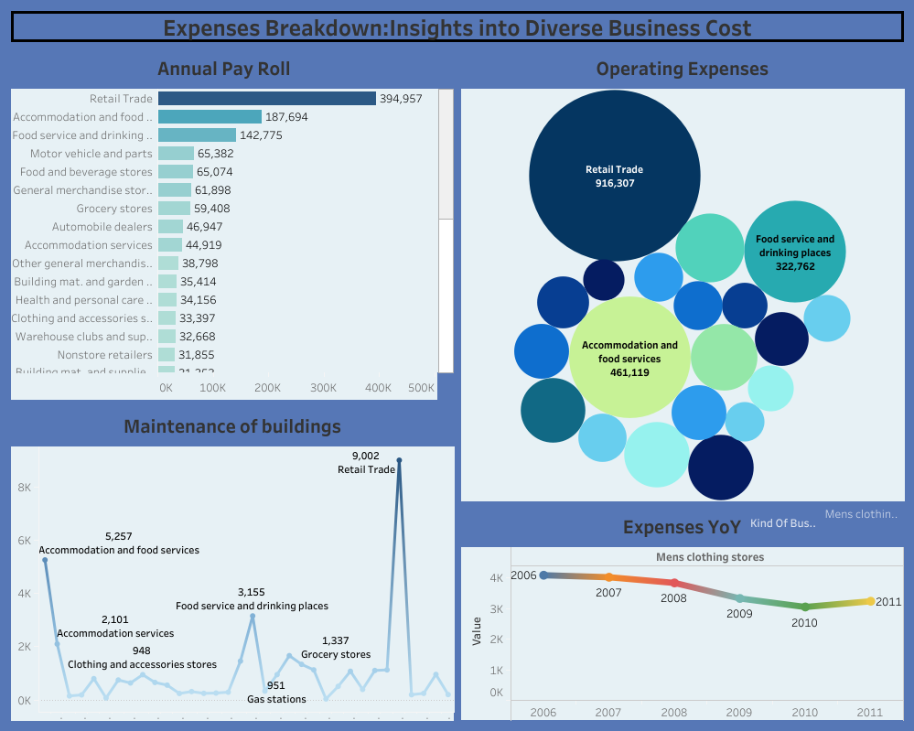

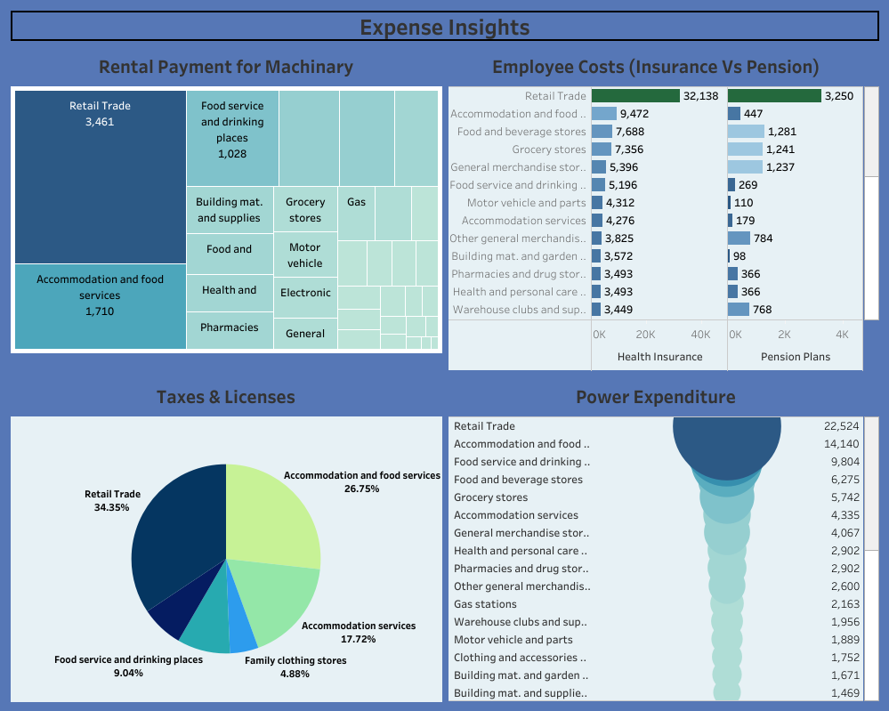

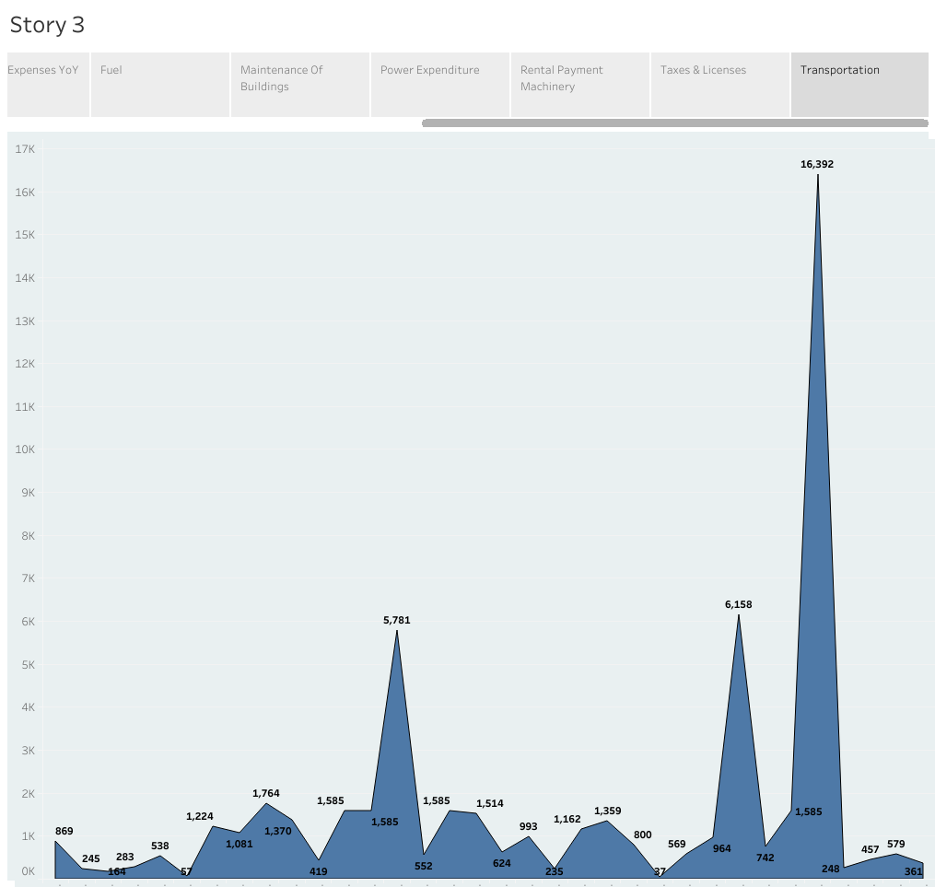

ADVANTAGES

These benefits include budget planning, resource allocation, risk management, improved decision-making, and competitive advantage.

Using cost estimation, organizations can ensure the success of their projects and maintain a competitive edge in their respective industries.

DISADVANTAGES

Costing methods are typically not useful for figuring out tax liabilities, which means that cost accounting can't provide a complete analysis of a company's true costs.

FUTURE SCOPE

Cost estimation in project management is the process of forecasting the financial and other resources needed to complete a project within a defined scope.

Cost estimation accounts for each element required for the project — from materials to labor — and calculates a total amount that determines a project's budget.